Information on Writing a White Paper and Use of this Document

“A white paper is a persuasive essay that uses facts and logic to promote a certain product, service, or viewpoint.”

In this case you are promoting what you have done in your project. This means you have to report on your developed tool, technology, design or arte-fact. Remember not to write in the first person in any section of your report.

How to use this form:
This document is only a template. You must change the content under the headers and replace it with your own material. You may also create your own document, but make sure you adhere to the structure outlined in this document.

Checklist before you submit your white paper:
- Proof read your document and use the spell/grammar check and correct any mistakes
- Check the format, e.g. are any images, tables, diagrams legible etc.
- Check whether your white paper looks professional, e.g., you should probably use a font that looks professional, not something that looks like a handwritten font (or indeed an illegible font); there should not be large areas of white space; spacing is consistent etc.
- Make sure you refer to figures, tables and references in the body of the text. (see Appendix C for examples for the format of figures and tables)
- Include your signed Deliverables & Requirements sheet in an Appendix.

Insert title of your report

You may want to provide a sub-title that clarifies what the benefit of your project is or the ultimate goal. The idea here is to capture your readers’ (i.e. your client’s) attention.
Insert your names
CMP311: Professional Project Development & Delivery
Insert your Programme name, e.g. BSc Ethical Hacking Year 3
2015/16

Note that Information contained in this document is for educational purposes.

Abstract or Executive Summary (not more than around 600 words)
This section should be an attention grabber. It should provide a short summary of what your paper is about so provide enough detail to satisfy your client that you met his/her needs and allows the reader to decide if the report is of interest. This is stand alone and should not refer to any other part of the document.

You should include 3 short sections:
• Background to the paper and aim of what you’re trying to achieve.
• What you did (and how).
• What you found and what you conclude from your findings (not too much detail but enough to show that your project is clearly wonderful). Not all projects are a success – and that’s ok too for the purpose of this work, and you can point that out – but preferably with solutions.

+Contents
1 Introduction 1
1.1 Background 1
1.2 Aim 1
2 Procedure 3
2.1 Overview of Procedure 3
2.2 Procedure part 1 3
3 Results 4
3.1 Results for part 1 4
4 Discussion 5
4.1 General Discussion 5
4.2 Countermeasures (for a project in ethical hacking) 5
4.3 Conclusions 5
4.4 Future Work 5
4.5 call to action 6
References 7
Appendices 9
Appendix A 9
Appendix B 9
Appendix C - Suggestions for formatting figures/tables/screenshots in the body of the text 9
Appendix D - Include your project deliverables and requirements sheet 10

Introduction

Background
Here, you need to ‘hook in’ your audience. This section introduces the report, i.e. sets out what the report is all about. Provide the background to the work and the brief - define the context and critical issue of your project and provide a generic discussion to build up the credibility of your product. Consider, for example, why it is important to do this work.
Identify the ‘business problem’ your technology/code/design solves. Make sure that you write in a way that entirely addresses the problem from the perspective of the target audience. Write in the Present Tense.
- Provide a background into the subject area.

- Introduce what the technology/design/etc. is – definition? What it does?

- Problems with the technology? Describe the problems in the area that you will be trying to solve. What are the technology/designs/tools out there that could do the job, but can’t cut the mustard – provide reasons for this. Naturally, whatever you do is so much better than anything else – make a case for it.

- Support your arguments with facts and figures, press quotes etc.

- Graphs illustrating the problem are good in here too.

- Do not include any of your work or findings at this stage of the report, remember it is an introduction to the problem.

- Use references to back up your work (see end of document for examples); you can also use references for all the following section where appropriate, e.g., to justify your procedure or to relate to novel developments in your discussion.

Aim
The aims of this project.
- Be general (high-level) and specific.

- Clearly state the objective(s) of the work you did. What did you expect to do in this project?

Procedure

Overview of Procedure
In the previous section you have explained the problem in detail. Now describe how you solved it in detail. Consider why your solution is so much better than anybody else’s. From now on use Past Tense.

- There should not be too much detail since you are aiming at a technical user (i.e. a fellow student).

- If you are using software, web designs prototypes etc. then screenshots of important features should be included here – with descriptions. If it is a hardware project then pictures / diagrams should be included here. These should be clearly labelled (for example “Figure 1 list of wireless LANS”) and referenced in the text. For example “see Figure 1 for an example of the results at this stage in the project”

- There should be no analysis of the results at this stage. This will be looked at in the discussion.

- Note that a reader should be able to re-create your work from this description. When you write this section, keep this in mind.

- Note:- For some assessments, you may wish to combine Procedure & results into one section.

Procedure part 1
- Use as many sub-headings in the Procedure as you think are necessary

Results
Put your results in here. Any tables or results should be included here unless there is a large amount of data. Appendices should be used for large amounts of data and referenced in the text. Only important details should be included in this section, i.e. material that convinces your client about the (hopefully fantastic) performance of your design/tool/etc.

Results for part 1
- Include results for part 1

- Use as many sub-headings as necessary.

Discussion

General Discussion
Here, you want to discuss your results/outcomes.

- What does it all mean? Discuss anything of interest. How does this relate to other work in this area (if relevant)?

- Relate the findings back to your aims - how well have you met your aim?

- Discuss, for example, return on investment (ROI), usability, adherence to standards, and speed of implementation. Ensure that you make clear you understand your client’s pain and can relieve it.

Countermeasures (for a project in ethical hacking)
- You may wish to discuss countermeasures if this is appropriate, or describe any future work that could be undertaken based on your project (you do not have to include 4.4 in this case).

Conclusions
- Provide a brief summary of the benefits of your solution for the client and what would happen if they did not use it.

- Any conclusions that you have should be short and “to the point”.

- Finish with the most important point you want the client to remember. Write this part as if it were a standalone document, i.e. imagine your clients would only read this part - list your most important selling points.

Future Work
- What would you do if given more time and resources?

call to action
- ‘Wet’ your client’s appetite to use your product, e.g., what could you do for them for free? E.g. free trial version, training etc.

- Provide contact information or a url that they can use to get in contact with you for further information (you can make this up).

References
For URLs, Blogs:
Bremer, J. 2012. x86 API Hooking Demystified. [blog]. 2 July. Available from: http://jbremer.org/x86http://jbremer.org/x86-api-hooking-demystified/api-hooking-demystified/ [Accessed 15 April 2016].
Bremer, J. 2012. x86 API Hooking Demystified. [online image]. Available from: http://jbremer.org/x86-api-hooking-demystified/ [Accessed 15 April 2016].
Google Chrome. 2016a. Manifest File Format. [online]. Available from:
https://developer.chrome.com/extensions/manifest [Accessed 15 April 2016].
Google Chrome. 2016b. chrome.webRequest. [online]. Available from: https://developer.chrome.com/extensions/webRequest [Accessed 15 April 2016].
Lelli, A. 2010. The Trojan.Hydraq Incident: Analysis of the Aurora 0-Day Exploit. [blog]. 21 January. Available from: http://www.symantec.com/connect/blogs/trojanhydraq-incident-analysis-aurora-0http://www.symantec.com/connect/blogs/trojanhydraq-incident-analysis-aurora-0-day-exploitday-exploit [Accessed 15 April 2016].

For Books:
Dahl, R., 2004. Charlie and the chocolate factory. 6th ed. New York: Knopf.

For Citations in Books:
Desikan, S. and Ramesh, G., 2006. Software testing. Bangalore, India: Dorling Kindersley, p.156.

For Chapters in Books:
Bressler, L., 2010. My girl, Kylie. In: L. Matheson, ed., The Dogs That We Love, 1st ed. Boston: Jacobson Ltd., pp. 78-92.

For Journals:
Ross, N., 2015. On Truth Content and False Consciousness in Adorno’s Aesthetic Theory. Philosophy Today, 59(2), pp. 269-290.

For Journals Accessed via a Database/Website:
Raina, S., 2015. Establishing Correlation Between Genetics and Nonresponse. Journal of Postgraduate Medicine, [online] Volume 61(2), p. 148. Available at: http://www.proquest.com/products-services/ProQuest-Research-Library.html [Accessed 8 Apr. 2015].

For other examples see: http://libweb.anglia.ac.uk/referencing/harvard.htm

Appendices

Appendix A
Put any large amounts of data here (e.g. code).

Hello.Php
<html>
<head>
<title>PHP Test</title>
</head>
<body>
<p>Hello World</p>
</body>
</html>

Appendix B
And here….

Appendix C - Suggestions for formatting figures/tables/screenshots in the body of the text

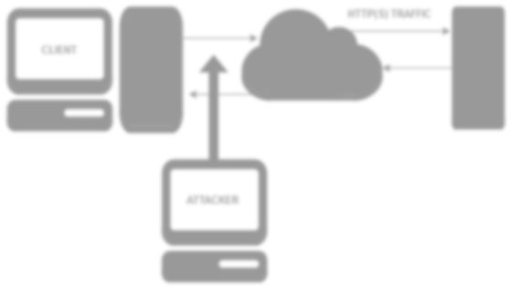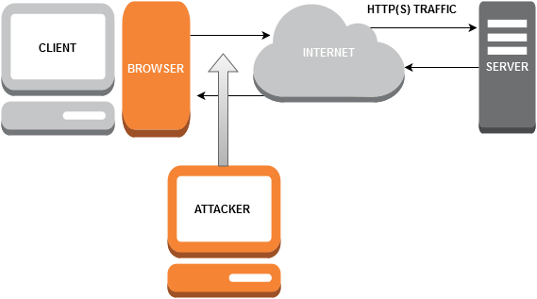
Figure 1-1 A diagram of the system that was used in the security test.

Table 1-1 Advantages of the X versus Y

Advantage Description
1 | Can be programmed easier.
2 | More flexible that the traditional system.
3 | More secure than the traditional setup.

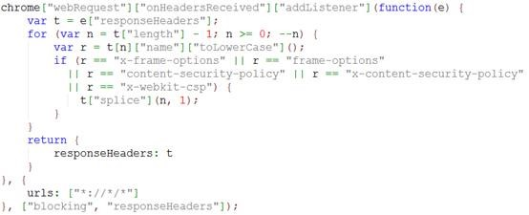

Figure 1-1 Snippets of code can be formatted like this.

Appendix D - Include your project deliverables and requirements sheet

Document prepared and revised by Natalie Coull, Colin McLean, Andrea Szymkowiak
Graham, G., 2005. The White Paper FAQ (Frequently Asked Questions)/That White Paper Guy – Gordon Graham. [online] Available at < https://www.thatwhitepaperguy.com/white-paper-faq-frequently-asked-questions/#what_is> [Accessed 9 May 2016].

